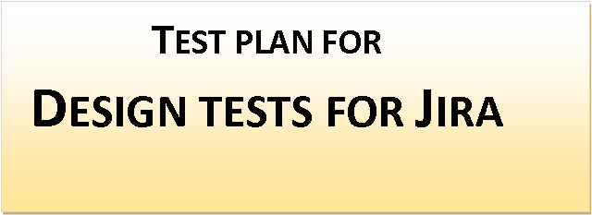

*ChangeLog*

|  |  |  |  |
| --- | --- | --- | --- |
| **Version** | **Change Date** | **By** | **Description** |
| 1.0.1 | 01.11.2022 | Alex | Test plan of Design tests for Jira project |
|  |  |  |  |

**1** **Introduction**

This document is intended to give a complete planning of ‘Design tests for Jira’ project.

## **1.1** **Scope**

### **1.1.1** **In Scope**

* Black-box testing
* Smoke testing
* Functional testing
* Security testing

### **1.1.2** **Out of Scope**

* UAT

## **1.2** **Quality Objective**

* Ensure the Application Under Test conforms to functional and non-functional requirements
* Ensure the AUT meets the quality specifications defined by the client
* Bugs/issues are identified

## **1.3** **Roles and Responsibilities**

* Test Manager
* Test Team

Amongst others

### 

# **2** **Test Methodology**

## **2.1** **Overview**

Test methodology:

* Waterfall

## **2.2** **Test Levels**

* System test by test team

## 

## **2.3** **Bug Triage**

Weekly meetings with participants to evaluate, prioritize and assign the resolution of defects:

* Priority: the order in which a defect should be fixed. Higher the priority the sooner the defect should be resolved.
* Severity: a degree of impact a bug has on the operation of the product.
* Updates are captured in bug tracking system

## **2.4** **Suspension Criteria and Resumption Requirements**

* Suspension criteria: text execution is blocked
* Resumption criteria: if unblocking is successful

## **2.5** **Test Completeness**

* 100% test coverage
* All Test cases executed by each team member
* All open bugs are identified and will be fixed in next release

# **3** **Test Deliverables**

* Test Plan
* Test Strategy
* Test Cases
* Requirement Traceability Matrix
* Test Metrics
* Bug Reports
* Test Reports

# **4** **Resource & Environment Needs**

## **4.1 Test Team:**

* Gábor
* Alex
* Barbi
* Donát
* Rita

## 

## **4.2 Testing Tools**

* Test Execution and Logging Tool (Zephyr)
* Requirements Tracking Tool (Google Spreadsheets)
* Bug Tracking Tool (Jira)

## **4.3 Test Environment**

* Jira users: manual47, manual29, manual16, manual9, manual28
* Windows 8 and above
* Web browser (Chrome, Edge, Opera, Safari, Mozilla)

# **5** **Terms/Acronyms**

|  |  |
| --- | --- |
| TERM/ACRONYM | DEFINITION |
| AUT | Application Under Test |
| UAT | User Acceptance Test |